Project Title: BILLING MANAGEMENT SYATEM

Project Submitted by: ISHWOR KHATIWADA

BIT, 2nd Semester, Texas College of Management and IT

College Roll No.: ishwor.khatiwada_LC00017000772

Kathmandu, Nepal

Project Submitted to: Mr. Kumar Poudyal

Subject: Object Oriented Programming (C++)

Date: Dec. 27, 2020

Introduction :
Super market billing system is a simple application built in C++. This project uses basically two things – use of various functions and file handling.
The project is relatively simple to understand as there are just a few features. Listed below are the key features of this project:

- To Add new Entry for Billing
- Show Previous Entry

In the program at first user has to enter the total number of products purchased this is for the repetition of the loop for Nth times Repetition of loop.
IFSTREAM are which performs input/output operations on the file they are associated with i.e. data.TXT whereas, OFSTREAM represents the output file stream and is used to create files and to write information to files i.e. abc.TXT.

For switching between conditions switch case is used and 3various options are provided.

Output Screenshots:

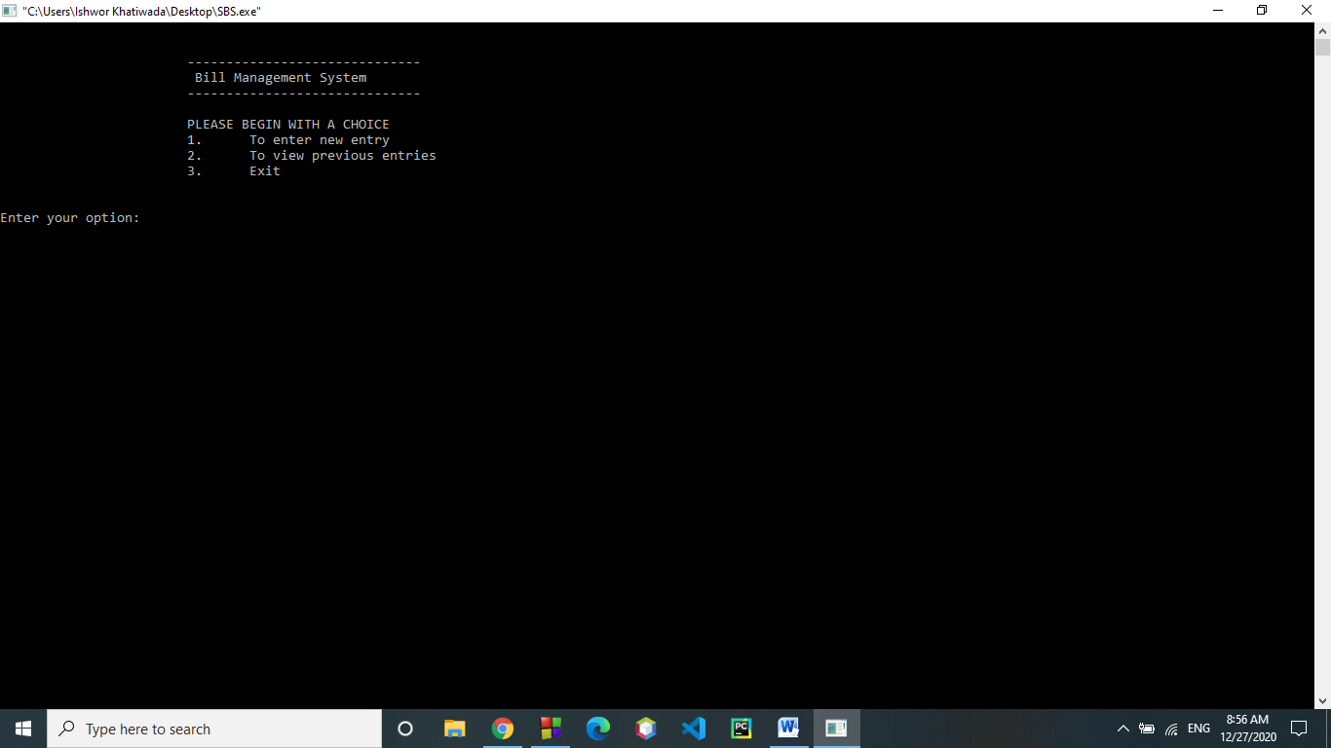

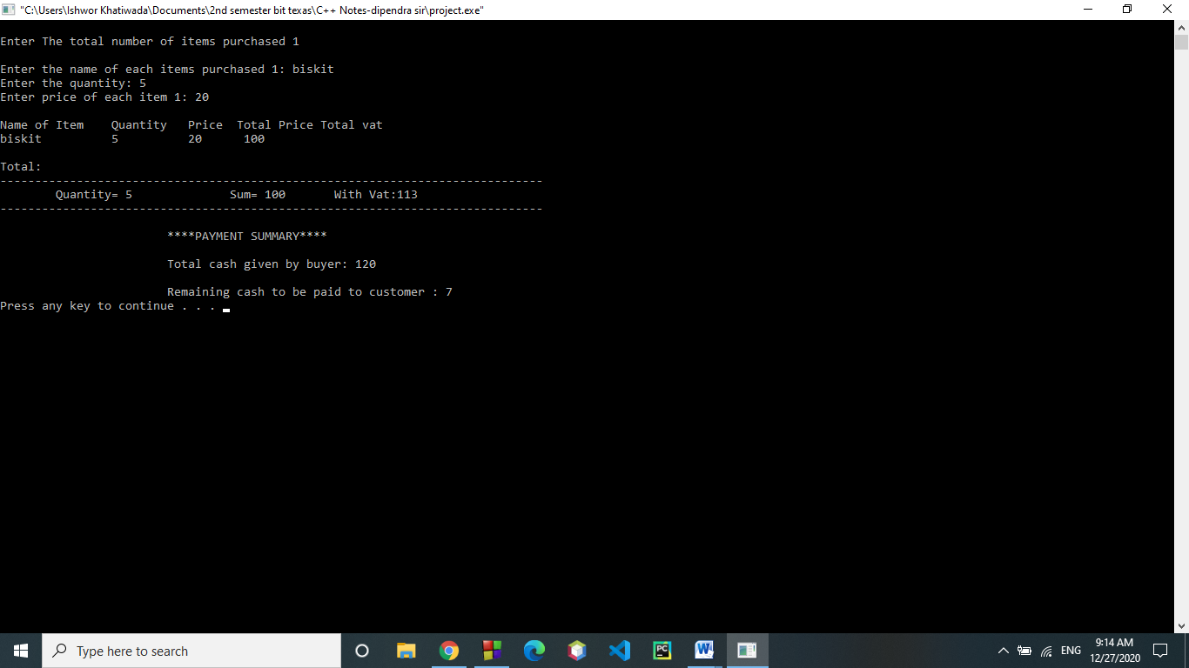

SOURCE CODE:

#include<iostream>
#include<process.h>
#include<fstream>
#include <stdlib.h>
using namespace std;

class head
{
char Iname[50][50];

public:
int totalitems;
float Qty[3];
float price[3];
int vatprice[3];
int tprice[3];
void input();
void output();
};
class vat:public head
{
float vats;
public:
void vatcal();
void outputs();
void sum();
};

// INPUT FUNCTION

void head::input()
{
system("CLS");
cout<<"\nEnter The total number of items purchased ";
cin>>totalitems;

for(int i=0; i<totalitems; i++)
{
cout<<"\nEnter the name of each items purchased "<<i+1<<": ";
cin>>Iname[i];
cout<<"Enter the quantity: ";
cin>>Qty[i];
cout<<"Enter price of each item "<<i+1<<": ";
cin>>price[i];
tprice[i]=Qty[i]*price[i];
}
}
// OUTPUT FUNCTION

void head::output()
{
int a;

ifstream infile("data.TXT");
infile>>a;

ofstream outfile("data.TXT");
a+=1;
outfile<<a;
outfile.close();

{ofstream outfile("abc.TXT", ios::app);
outfile<<endl<<"Bill No.: "<<a<<endl;
outfile<<"------------------------------------------------------------------------"<<endl;
cout<<"\n";
cout<<"Name of Item\tQuantity Price Total Price Total vat\n";
for(int i=0;i<totalitems;i++)
{
outfile<<"Name: "<<Iname[i]<<" Qty: "<<Qty[i]<<" Price: "<<tprice[i]<<"vat:"<<vatprice[i]<< endl;
cout<<Iname[i]<<"\t\t"<<Qty[i]<<"\t "<<price[i]<<"\t "<<tprice[i]<< '\n';
}

outfile<<"------------------------------------------------------------------------"<<endl;
outfile.close();
}
}

// VAT CALCULATION

void vat::vatcal()
{
input();
for(int i=0;i<totalitems;i++)
{
vatprice[i]=tprice[i]+(0.13*tprice[i]);

}
}
// VAT OUTPUTS

void vat::outputs()
{
output();

float cash=0,sum=0,qty=0,sumt=0;

for(int i=0;i<totalitems;i++)
{
sumt+=tprice[i];
sum+=vatprice[i];
qty+=Qty[i];
}
cout<<"\nTotal:";
cout<<"\n------------------------------------------------------------------------------";
cout<<"\n\tQuantity= "<<qty<<"\t\t Sum= "<<sumt<<"\tWith Vat:"<<sum;
cout<<"\n------------------------------------------------------------------------------";

pay:

cout<<"\n\n\t\t\t****PAYMENT SUMMARY****\n";
cout<<"\n\t\t\tTotal cash given by buyer: ";
cin>>cash;

if(cash>=sum)
cout<<"\n\t\t\tRemaining cash to be paid to customer : "<<cash-sum<<'\n';

else
{ cout<<"\n\t\t\tCash given is less than total amount!!!";

goto pay;
}
}

// THE MAIN FUNCTION OF PROGRAM

int main()
{
vat obj;
char opt, ch;
int a=1;
ifstream fin;

do{
start:
system("PAUSE");
system("CLS");
cout<<"\n\n\t\t\t------------------------------";
cout<<"\n\t\t\t Billing Management System";
cout<<"\n\t\t\t------------------------------";
cout<<"\n\n\t\t\t ENTER YOUR CHOICE TO BEGIN";
cout<<"\n\t\t\t1.\t For New Entry\n\t\t\t2.\tTo view previous entries\n\t\t\t3.\tExit\n";
cout<<"\n\nEnter your option: ";
cin>>opt;
switch(opt)
{
case'1':
obj.vatcal();

obj.outputs();
goto start;
case'2':

fin.open("abc.TXT", ios::in);
while(fin.get(ch))
{
cout<<ch;
}
fin.close();

goto start;
case'3':
exit(0);
default:
cout<<"\a";
}

}while(opt!=3);

}

